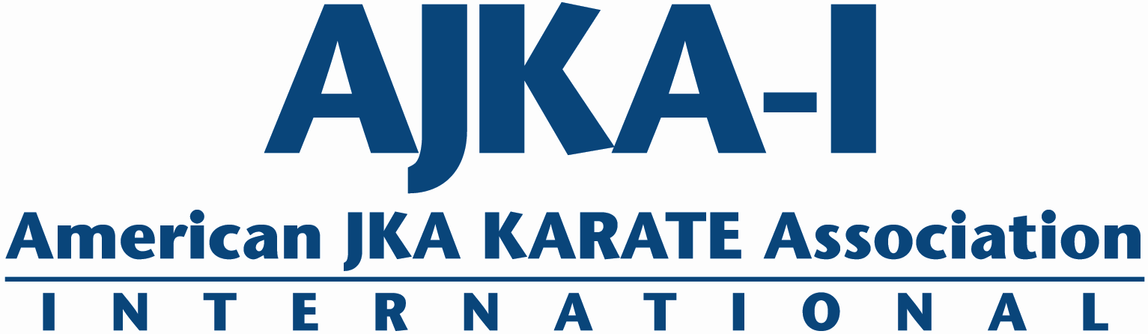
Fee Schedule: (Register by Febuary 10th 2017 to receive discount on Whole Camp or Full Day packages)
AJKA Karate Association International
The Solebury Club
Traditional Shotokan Karate
Three Days of Pure World Class Shotokan!
Shotokan Symposium
Feb 24 – 26, 2017
$160 for all three days of training or
$45 a session, $80 a day

Register now! Space is limited!
Venue: The Solebury Club
4612 Hughesian Dr. Buckingham, PA 18912
www.thesoleburyclub.com
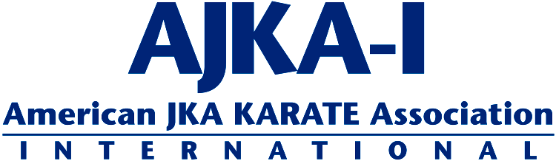
Dear Friends of Shotokan –
Join us February 24-26, 2017 for
3 days of the Best Shotokan Karate Training - Anywhere!
For Kids – “FIRST TIME” Kobudo training. Learn Bo kata (Shushi no kon sho). Bo kata will be taught in preparation to be used in upcoming AJKAI-I May tournament. Held by Andrew Spivack
For all level karate-ka – 3 separate training areas; specific Dan and Kyu rank training; and Specific Self-Defense and Kata Bunkai Training.
Leading this year Symposium will be the following AJKA-I Instructors:
- Sal Lopresti 8th dan – AJKA-I International Technical Committee. NJ
- Avi Azoulay, 7th dan – AJKA-I International Technical Committee. NY
- Rob DeAngelis, 7th dan – AJKA-I International Technical Committee. PA
- Kevin Warner, 7th dan – AJKA-I International Technical Committee. CA
- Morris Lawrence, 6th dan – AJKA-I National Technical Committee. MI
- David Gomez, 5th dan – AJKA-I Executive Committee Member, GA
- Ed Rumick, 5th dan – AJKAI –PA, Vice Chief Instructor, PA

As a group we are dedicated to providing an intense, challenging, and enjoyable weekend of world-class training and study.
Please read below for symposium logistics and information. Also feel free to contact me directly at 215-519-9310 or deangelis@ajkai-usa.com for further information.

Yours in Budo,
Rob DeAngelis

Sunday 2/26/17
9:00am – 10:00am
Dojo Adult All Levels

10:15am – 12:00pm
Dojo 1st Dan and Above
Studio 1 4th Kyu and Below
Studio 2 3rd Kyu and Above

1:00pm – 2:20pm (Individual Kata)
Dojo 1st Dan and Above
Studio 1 4th Kyu and Below
Studio 2 3rd Kyu and Above

2:30pm- 3:00pm (Camp Closing)
Dojo All Ranks
Saturday 2/25/17
7:00-8:00am
Dojo Adult All Levels
9:00-10:00am
Dojo Youth Training (BO Kata)
10:15am – 11:45am
Dojo 1st Dan and Above
Studio 1 4th Kyu and Below
Studio 2 3rd Kyu and Above
12:00-1:00pm
Dojo Youth Training Kata
1:00pm – 2:45pm
Dojo 1st Dan and Above
Studio 1 4th Kyu and Below
Studio 2 3rd Kyu and Above
3:00-4:00pm
Dojo Youth Training Kumite
Friday 2/24/17
7:00-9:00pm
Dojo Adult All Levels
Shotokan Symposium 2017
Training Schedule
***Note no early registration discounts for individual sessions or Youth Sessions
Whole Camp: $160
One day: $80
Any 1 Session: $45
Youth Single Session: $20
Youth All 3 Sessions: $50

ALL CHECKS PAYABLE TO: AJKAI-USA
OR PAY ONLINE: http://www.ajkai-usa.com/
Name:___________________________________________ Age:____ Gender:____ Address_____________________________________________________________ Home/cell #_____________________ Email Address _________________________ Sensei/Dojo________________________________ Your Rank _________________ Adult Class Registration:
CHECK: Full 3 days_____ =$160 Individual Sessions________ x $45 =________ Just
Saturday_____=$80 Just Sunday_____=$80 Saturday+Sunday_____=$160
Class Total $__________ (Pre-registration before Feb. 10th 2017, Whole Camp -$10, Full Day -$5)
= Registration Total $_________
Youth Class Registration (All Youth Sessions on Saturday):
CHECK: All 3 Youth Sessions_____ =$50 Any 2 Youth Sessions_____ =$40
Just 9am Session_____ =$20 Just 12pm Session_____ =$20 Just 3pm Session_____ =$20
Registration Total $_________
I, the undersigned do herby volunteer my application for the attendance and participation in the 2017 Shotokan Symposium, and do hereby assume full responsibility for all injuries, damages, or losses that I may sustain or incur, if any, while attending/participating. I do hereby waive all claims against AJKAI-USA, Solebury Club LLC, individually or otherwise, for any claims or injuries I may sustain. I fully understand that any medical treatment given to me will be first aid type only. I certify that I am in good health and without injuries or physical disabilities. I consent that any pictures furnished by me or taken of me in connection with the seminar can be used for publicity, promotion, or television showing and waive compensation in regard thereto. I further agree to conduct myself with decorum in the spirit of Karate-‐Do.
Signature................................................................................ Date.....................
Parent/Guardian (under 18)................................................................................
Please submit applications and fees to us for early processing. Must be received by Febuary 10th 2017.
Website: www.ajkai-usa.com Email: erumick@comcast.net
The Solebury Club, 4612 Hughesian Drive, Buckingham, PA 18912 Phone: 215-794-3494

